# PS：中文说明在英文之后

# One. Environment configuration

# 1.1 Hardware requirements:

CPU> = 2.4G Hz

Memory> = 4G

Kinect v1.0

Data Glove Ultra 14 glove equipment

LMPS-B2 Bluetooth device

# 1.2 Development environment configuration:

1. Download and install Unity3D 2017.3.0f or later

2. Download and install Kinect SDK v1.8 (currently Unity3D only supports this version)

3. Unzip Boneknitting Technique.zip to any directory without Chinese name, use Unity to open the project root directory

Note: (1) If there is a problem that the red light in the middle does not turn on after Kinect is connected, or the device is not always connected, you can try to disable the camera of the system and uninstall the camera driver

(2) Project path must not display Chinese

# 1.3 Operating environment configuration

Install Kinect SDK v1.8

# two. Project directory introduction

# 2.1 Assert directory

Material: Store the material balls you created in the project, you can create subdirectories as needed

Models: store the model files used in the project. Since many models used in the project are from the Sky_City scene, the model files in this directory are not complete

Plugin: Stores some scripts needed for Kinect development and Sky_city scene resource files. Most of the art resources in this project come from this scene.

Resources: Prefab files in the project

Scenes: Store scene files in the project

Scripts: Store all code files during project development, except for third-party code. For example, the previous Kinect scripts are placed in the Plugins folder.

Shader: all shader files created in the project

Sprites: all UI image resource files in the project

StreamingAssets: resource files that need to be managed independently in the project, this folder will not do any processing when Unity is packaged

Now used to store recorded method data files, avatar data, and LPS programs

Textures: used to store texture files created in the project

2.2 Resource directory

UIPrefabs: Store UI prefabs

Doctor: a prefabricated model of a doctor in a scene, recording scenes, playing scenes, learning scenes to use

DoctorRef: The doctor model controlled by reference data in the learning scene is actually basically the same as the Doctory model, except that the KinectManager script has been deleted. In order to solve the program stall problem caused by the two KinectManager scripts running at the same time

SkyCity: Prefabricated environment in the scene

## 2.2.1 UIPrefabs directory

Chart:

 Encapsulation of a single chart in chart drawing, that is, directly placed in the scene is a curve such as a speed curve

ChartCanvas

There are 4 graphs in the entire chart, but only two graphs are shown in the scene

CampairItem

Prefabricated items in list in learning mode with click response script

MovieListItem

Prefab of list item in Start scene with click response script

PlayModeCanvas

The prefabricated part of the entire UI in the play mode, which has all the scripts needed for the UI in the play mode.

Ranch

TimeSlide: Slider implementation

MiniMap: Originally a small window, this function was cancelled later

ControlPanel: the right control button in playback mode

RecordModeCanvas

The prefabricated part of the entire UI in the recording mode, which hangs most of the scripts required by the UI in the recording mode.

Ranch

RecordControlPanel: those calibrations when recording mode starts recording, start recording, stop recording button

Return: Back button

ChartSwitch: chart switch button

SaveControlPanel: UI after stopping recording, including crop slider, file save panel

CutSilder has a script for controlling the double-end slider DoubleEndSlider-

StartSceneCanvas

Prefabrication of the entire UI in the start scene, hanging all the scripts needed for the UI in the start scene

MenuBar: top menu bar

MovieExhibition: Show list

StudyModeCanvas

Prefabrication of the entire UI in the learning mode, which hangs most of the scripts required by the UI in the learning mode

Ranch

Return: Back button

StudyUIPanel: UI before the learning mode officially starts, such as selecting data and preparing

ComPairMovieList: List displayed when data is selected in learning mode

StudyPanel:

Ranch

StartStudy: Start learning

ChartSwitch: chart switch

Result: Learning result display panel

WarningText

A warning box that pops up when you delete items from the list in the scene.

# 2.3 Scripts Directory Introduction

It is recommended to read the module division in the structure design of the traditional Chinese medicine orthopedic program before looking at this part

CoreLogic: all the code files of the core logic layer, and the code files required by the core logic layer

ServiceLogic: The code file of the Controller layer in the business logic layer, which is reflected in the class diagram of the program design

Tool: some tool scripts or tool classes used in the project, such as configuration files, or some tool function files

UIScript: UI script file that handles UI logic, including the Manager layer responsible for UI interaction

Main file: The first script run by the project, where you can initialize the program, set it up, and so on.

# 一．环境配置

## 1.1硬件需求：

CPU>=2.4G Hz

内存>=4G

Kinect v1.0

Data Glove Ultra 14 手套设备

LMPS-B2蓝牙设备

## 1.2开发环境配置:

1. 下载安装Unity3D 2017.3.0f以上版本
2. 下载安装Kinect SDK v1.8 (目前Unity3D只支持到此版本)
3. 解压Boneknitting Technique.zip到任意无中文名的目录下，使用Unity打开项目根目录

注：（1）若出现Kinect连接后中间红灯不亮的问题，或一直提示设备未连接问题，可尝试禁用系统的摄像头，卸载摄像头驱动

(2) 项目路径不得出现中文

## 1.3运行环境配置

安装Kinect SDK v1.8

# 二．项目目录介绍

## 2.1 Assert目录

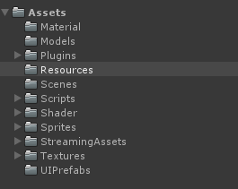

Material：存放项目中自己创建的材质球，可自行根据需要创建子目录

Models：存放项目中使用的模型文件，由于项目中使用的许多模型都是来自Sky_City场景，因此此目录下模型文件并不完整

Plugin：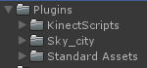存放了Kinect开发所需的一些脚本，以及Sky_city场景资源文件，本项目中大多美术资源来自此场景

Resources：存放项目中的预制件文件

Scenes：存放项目中的场景文件

Scripts：存放项目开发过程中所有的代码文件，第三方代码除外，如之前的Kinect脚本放在Plugins文件夹中。

Shader：项目中创建的所有shader文件

Sprites：项目中所有的UI图片资源文件

StreamingAssets：项目中需要自主管理的资源文件，Unity打包时不会对此文件夹做任何处理

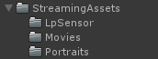现用于存放录制后的手法数据文件以及头像数据还有Lps程序

Textures：用于存放项目中创建的纹理文件

## 2.2 Resource目录

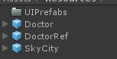

UIPrefabs：存放UI预制件

Doctor：场景中医生模型预制件，在录制场景，播放场景，学习场景使用

DoctorRef：学习场景下的参考数据控制的医生模型，实际上和Doctory模型基本是一样的，只是删除了KinectManager脚本，为了解决两个KinectManager脚本同时运行导致的程序卡顿问题

SkyCity：场景中环境预制件

### 2.2.1 UIPrefabs目录

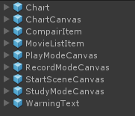

Chart：

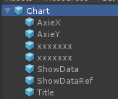

图表绘制中单个图表的封装,即，直接放在场景中就是一个曲线如速度曲线

ChartCanvas

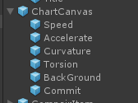

整个图表，共有4个图，但场景中只展示了两个图

CampairItem

学习模式下列表中项的预制件，其上挂了点击响应脚本

MovieListItem

Start场景中列表项的预制件，其上挂了点击响应脚本

PlayModeCanvas

播放模式下整个UI的预制件，其上挂了所有播放模式下UI所需的脚本

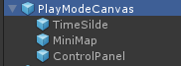

TimeSlide：滑动条实现

MiniMap：原本是小窗口，后面取消了这一功能

ControlPanel：播放模式下右边的控制按钮

RecordModeCanvas

录制模式下整个UI的预制件，其上挂了大部分录制模式下UI所需脚本

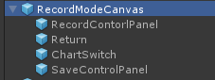

RecordControlPanel：录制模式开始录制时的那些校准，开始录制，停止录制按钮

Return：返回按钮

ChartSwitch：图表开关按钮

SaveControlPanel：停止录制后的UI，包括裁剪滑动条，文件保存面板

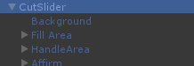

CutSilder上挂了用于控制双端滑动条的脚本DoubleEndSlider-

StartSceneCanvas

开始场景中整个UI 的预制件，挂了开始场景中UI所需的所有脚本



MenuBar：顶端菜单栏

MovieExhibition：展示列表

StudyModeCanvas

学习模式下整个UI的预制件，挂了学习模式下Ui所需的大部分脚本

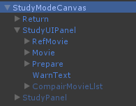

Return：返回按钮

StudyUIPanel：学习模式正式开始前的UI，如选择数据，准备

ComPairMovieList：学习模式下选择数据时展示的列表

StudyPanel：

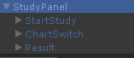

StartStudy：开始学习

ChartSwitch：图表开关

Result：学习结果展示面板

WarningText

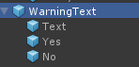

开始场景中的删除列表中项目时弹出的警告框。

## 2.3 Scripts目录介绍

建议先阅读中医正骨程序结构设计中的模块划分再来看这部分

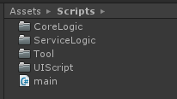

CoreLogic：核心逻辑层所有代码文件，以及核心逻辑层所需的代码文件

ServiceLogic：业务逻辑层中Controller层的代码文件，在程序设计 的类图中有所体现

Tool：项目中使用到的一些工具脚本或工具类，如配置文件，或一些工具函数文件

UIScript：UI脚本文件，处理UI逻辑，其中负责于UI交互的Manager层也在内

Main文件：项目运行的第一个脚本，可以在其中进行程序初始化，设置等等。